Assignment 5 — Threat Hunting Concept

1. Introduction
Threat hunting is a proactive cybersecurity process used to identify potentially malicious activity that may not be detected by traditional security controls. Instead of waiting for an alert, the analyst starts with a hypothesis about possible malicious behavior and investigates available telemetry to confirm or reject it.
The main goal of this assignment is to apply a hypothesis-driven threat hunting approach to network traffic from the CIC-DDoS2019 dataset. The investigation focuses on two DDoS attack scenarios: SYN flood and UDP-based flood traffic. Splunk is used as the main platform for querying and investigating the network telemetry.
The investigation follows the general process:
Hypothesis → Data → Hunt Query → Observation → Validation → Verdict

2. Threat Hunting Methodology
The investigation uses a hypothesis-driven approach. Each hunting scenario begins with a specific hypothesis describing potentially malicious behavior.
The analysis focuses on observable network characteristics rather than directly searching for known attack labels. The Label field from CIC-DDoS2019 is used later as ground truth to validate the hunting results.
Two complementary approaches are considered:

Intelligence-driven hunting
Threat intelligence about DDoS attacks can be used to identify expected attack characteristics. For example, SYN floods commonly generate large volumes of TCP SYN packets, while UDP floods can generate high packet and byte rates.

Scenario-based hunting
The investigation models realistic attack scenarios:
- An attacker generates a large amount of SYN traffic against a specific target.
- An attacker generates a large amount of UDP traffic against a specific target, potentially using multiple source addresses.
The investigation therefore focuses on:
- destination concentration;
- source IP diversity;
- packet rate;
- byte rate;
- SYN and ACK flag behavior;
- protocol;
- temporal distribution of traffic.

3. Dataset
The CIC-DDoS2019 dataset was selected as the source of network telemetry. The dataset contains network flow records representing both benign and malicious traffic.
The investigation focuses primarily on the following labels:
- Syn
- UDP-lag
- BENIGN
The dataset also contained WebDDoS records, which were not selected as one of the main hunting scenarios.
After preprocessing, the dataset contained approximately 1.95 million flow records.
The observed distribution was:
Label | Number of Records
Syn | 1,582,289
UDP-lag | 366,461
BENIGN | 4,097
WebDDoS | 439
Total | 1,953,286
The Label field was not used as the initial hunting condition. Instead, it was retained for later validation of the hunting results.

4. Data Preparation
Before importing the data into Splunk, the raw CIC-DDoS2019 CSV files were processed using a Python preprocessing pipeline.
The processing pipeline was:
Raw CIC-DDoS2019 CSV
↓
Filtering
↓
Normalization
↓
Relevant telemetry selection
↓
Splunk
↓
Threat Hunting

4.1 Filtering
The filtering stage removed unnecessary or invalid records and fields.
The original dataset contains a large number of features. Only fields relevant to the selected hunting scenarios were retained.
Examples include:
- Source IP
- Source Port
- Destination IP
- Destination Port
- Protocol
- Timestamp
- Flow Duration
- Flow Packets/s
- Flow Bytes/s
- SYN Flag Count
- ACK Flag Count
- RST Flag Count
- PSH Flag Count
- Packet Length Mean
- Packet Length Std
- Label
The unnecessary Unnamed: 0 index column was removed.
Rows missing critical network information such as source IP, destination IP, protocol, or label were also filtered.

4.2 Normalization
The normalization stage standardized the values used during the investigation.
Examples included:
- removing unnecessary whitespace from column names;
- cleaning IP address fields;
- normalizing labels;
- converting protocol values to numeric form;
- converting numeric network features into appropriate numeric values.
Private IP addresses were not removed because CIC-DDoS2019 is a controlled network dataset and addresses such as 172.16.x.x represent meaningful laboratory network telemetry.

4.3 Data Separation
The processed data was also separated by the original dataset labels into separate files for easier inspection and validation.
The resulting structure was:
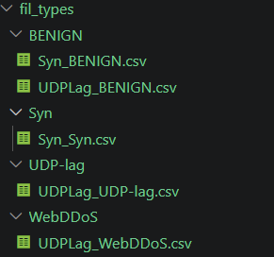
This separation was used for dataset inspection and validation. The primary hunting investigation in Splunk was performed on the normalized data rather than relying on the attack label as the initial search condition.

5. Threat Hunting Hypothesis 1 — SYN Flood

5.1 Hypothesis
An attacker may be performing a SYN flood attack against a specific target, generating a high volume of TCP SYN traffic toward a destination, with a significant imbalance between SYN and ACK packets.
The hypothesis is based on the expected characteristics of SYN flood attacks.
The main indicators investigated were:
- TCP traffic (Protocol = 6);
- high SYN packet volume;
- low ACK volume compared with SYN;
- high packet rate;
- concentration of traffic on a specific destination;
- potentially multiple source IP addresses targeting the same destination.

5.2 Hunt Query 1 — Destination Concentration
The first query was used to identify destinations receiving large amounts of TCP traffic.
Protocol=6
| stats count as flows
dc("Source IP") as unique_sources
dc("Destination Port") as unique_ports
sum("SYN Flag Count") as syn
sum("ACK Flag Count") as ack
avg("Flow Packets/s") as avg_pps
by "Destination IP"
| eval syn_ack_ratio=round(syn/(ack+1),2)
| sort - flows

Purpose
The query groups traffic by destination IP and measures:
- total number of flows;
- number of unique source IP addresses;
- number of destination ports;
- total SYN packets;
- total ACK packets;
- average packet rate.

Observation
The analysis showed that the majority of TCP SYN traffic was concentrated on 192.168.50.1
The destination received approximately 92433 flows from 1 unique source IP addresses.
We had only 1 unique source IP because it’s training set and all flood was generated from 1 IP - 172.16.0.5

5.3 Hunt Query 2 — Investigation of 172.16.0.5
During the initial investigation, 172.16.0.5 appeared to be strongly associated with the SYN traffic.
To determine whether the address represented a source or a target, both directions were investigated.

Source investigation
"Source IP"="172.16.0.5"
| stats count as flows
dc("Destination IP") as unique_destinations
dc("Destination Port") as unique_ports
sum("SYN Flag Count") as syn
sum("ACK Flag Count") as ack
avg("Flow Packets/s") as avg_pps
by "Source IP"
| eval syn_ack_ratio=round(syn/(ack+1),2)

Destination investigation
"Destination IP"="172.16.0.5"
| stats count as flows
dc("Source IP") as unique_sources
dc("Destination Port") as unique_ports
sum("SYN Flag Count") as syn
sum("ACK Flag Count") as ack
avg("Flow Packets/s") as avg_pps
by "Destination IP"
| eval syn_ack_ratio=round(syn/(ack+1),2)

Observation
The investigation showed that 172.16.0.5 was primarily observed as a SOURCE.
The address was associated with approximately 93315 flows and 1 unique communicating hosts.
This result was important because it allowed the investigation to distinguish between a potential attacker source and an attacked destination.

6. SYN/ACK Imbalance
A SYN flood is expected to produce a significant difference between SYN and ACK traffic.
The following query was used:
Protocol=6
| stats sum("SYN Flag Count") as syn
sum("ACK Flag Count") as ack
count as flows
dc("Source IP") as unique_sources
by "Destination IP"
| eval syn_ack_ratio=round(syn/(ack+1),2)
| where syn > 0
| sort - syn_ack_ratio

Observation
The destination 192.168.50.1 showed a SYN/ACK ratio of approximately 0.
The number of SYN packets was 10 while the number of ACK packets was 92421.
This indicates significant SYN/ACK imbalance.

7. Source Diversity
The next stage investigated whether the suspicious destination received traffic from multiple source addresses.
Protocol=6
| stats count as flows
dc("Source IP") as unique_sources
sum("SYN Flag Count") as syn
sum("ACK Flag Count") as ack
by "Destination IP"
| eval syn_ack_ratio=round(syn/(ack+1),2)
| sort - unique_sources

Observation
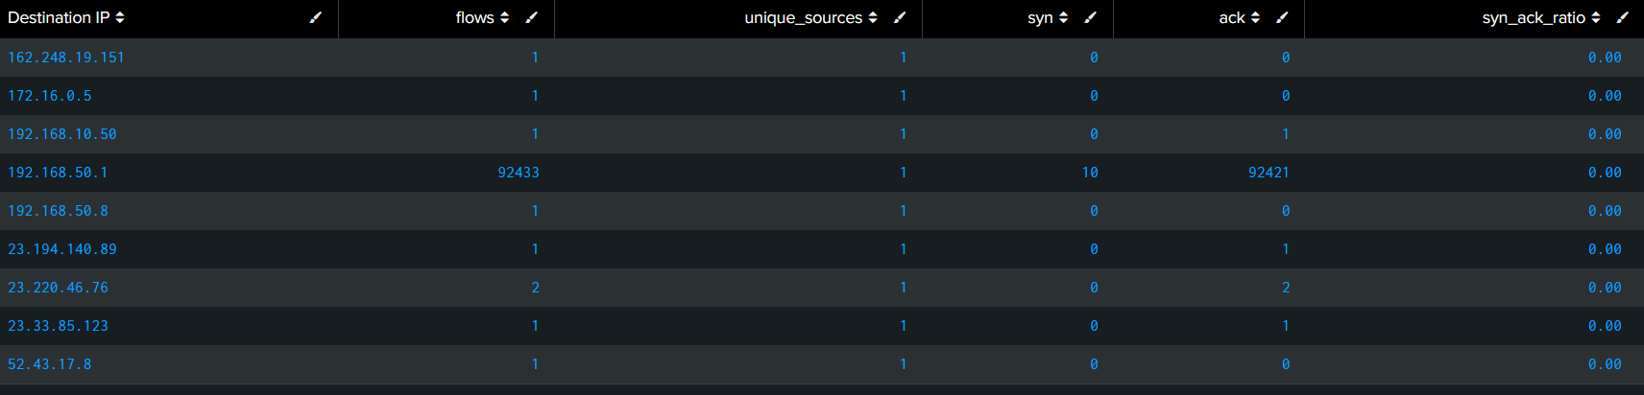
The suspicious destination received traffic from approximately 92433 unique source IP addresses.
This supports the hypothesis if the traffic is concentrated on one destination while originating from many different sources.

8. Temporal Analysis of SYN Traffic
The investigation was also performed over time to determine whether the suspicious traffic was concentrated in particular periods.
Protocol=6
| bin _time span=1m
| stats count as flows
dc("Source IP") as unique_sources
sum("SYN Flag Count") as syn
sum("ACK Flag Count") as ack
avg("Flow Packets/s") as avg_pps
by _time "Destination IP"
| eval syn_ack_ratio=round(syn/(ack+1),2)
| sort _time -flows

Observation
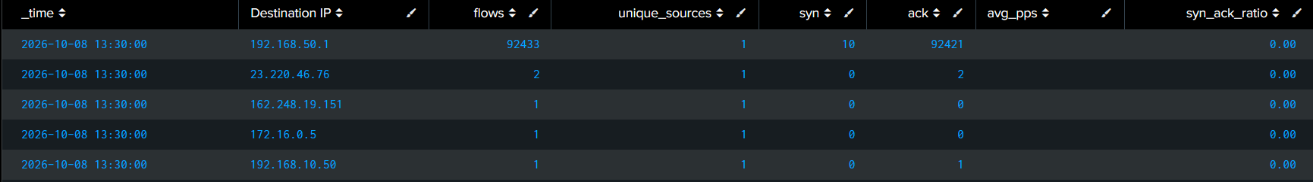
The highest observed activity occurred around 13:30 when the destination 192.168.50.1 received approximately 92433 flows.

9. SYN Hypothesis Validation
After identifying suspicious traffic based on network characteristics, the dataset labels were used for validation.
Example:

"Destination IP"="192.168.50.1"

| stats count by Label

| sort – count

Result
The label distribution was:
Label | Records
Syn | 92435
BENIGN | 14
UDP-lag | 881
Other | 0
The majority of records associated with the investigated destination were labeled SYN.

Verdict SUPPORTED
The hypothesis is SUPPORTED because Majority of requests was directed from one IP and had a lot of SYN request over short time to one dst IP.

10. Threat Hunting Hypothesis 2 — UDP Flood

10.1 Hypothesis
An attacker may be performing a UDP flood attack against a specific target, generating a high volume of UDP traffic toward one destination from multiple source IP addresses.
The main indicators investigated were:
- UDP traffic (Protocol = 17);
- high packet rate;
- high byte rate;
- concentration on a specific destination;
- multiple source IP addresses;
- temporal concentration of traffic.

11. UDP Destination Concentration
Protocol=17
| stats count as flows
dc("Source IP") as unique_sources
dc("Destination Port") as unique_ports
sum("Flow Packets/s") as packet_rate
sum("Flow Bytes/s") as byte_rate
by "Destination IP"
| sort - flows

Observation
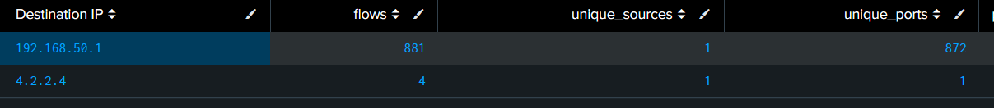
The analysis identified 192.168.50.1 as the most significant destination, with 881 flows and 1 unique source IP addresses.

12. UDP Source Diversity

Protocol=17

| stats count as flows

dc("Source IP") as unique_sources

sum("Flow Packets/s") as packet_rate

sum("Flow Bytes/s") as byte_rate

by "Source IP"

| sort - unique_sourcesObservation
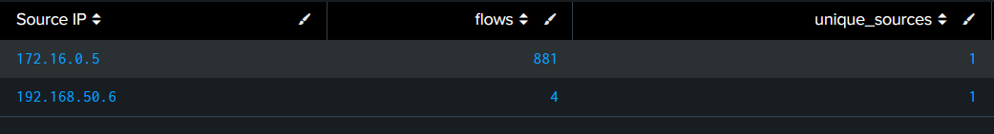
The suspicious destination received UDP traffic from 2 unique source IP addresses.
The packet rate was approximately 885 packets/s.
This behavior supports the hypothesis of a UDP flood.

13. Temporal Analysis of UDP Traffic
Protocol=17
| bin _time span=1m
| stats count as flows
dc("Source IP") as unique_sources
sum("Flow Packets/s") as packet_rate
sum("Flow Bytes/s") as byte_rate
by _time "Destination IP"
| sort _time -packet_rate

Observation
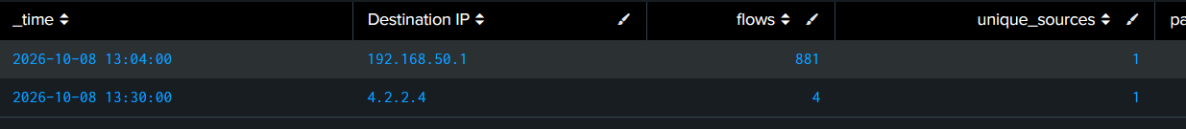
The UDP traffic was concentrated during 13:05 – 13:30.
The highest activity was observed against 192.168.50.1, reaching approximately 885 packets/s.

14. UDP Hypothesis Validation
After identifying the suspicious destination, the corresponding labels were examined.
Protocol=17 "Destination IP"="192.168.50.1
| stats count by Label
| sort - count

Result
The majority of the observed records were labeled UDP-lag

Verdict SUPPORTED
The hypothesis is SUPPORTED because Majority of packets was directed from one src IP to one dst IP at short time.

15. Findings
The investigation demonstrated how hypothesis-driven threat hunting can be applied to network flow telemetry.
For the SYN scenario, the investigation focused on:
- concentration of TCP traffic on a specific destination;
- SYN packet volume;
- SYN/ACK imbalance;
- source IP diversity;
- packet rate;
- temporal distribution.
For the UDP scenario, the investigation focused on:
- UDP protocol traffic;
- packet and byte rates;
- destination concentration;
- source IP diversity;
- temporal distribution.
An important observation during the investigation was the strong association between the SYN traffic and the IP address 172.16.0.5. Further investigation was required to determine whether the address represented the source or destination of the traffic.
The dataset labels were intentionally used only during the validation stage. This approach prevents the hunting process from simply searching for records already known to be malicious.

16. Limitations
There are several limitations to this investigation.
First, CIC-DDoS2019 is a controlled dataset and therefore does not represent all characteristics of traffic in a real production environment.
Second, the dataset is strongly imbalanced. The number of Syn and UDP-lag records is significantly larger than the number of benign records. Therefore, absolute traffic volume cannot be interpreted without considering the dataset composition.
Third, the investigation does not have a normal enterprise baseline. In a real environment, thresholds for packet rates, source diversity, and destination concentration would ideally be established from historical legitimate traffic.
Finally, the dataset contains labels that provide ground truth. In a real threat hunting investigation, the analyst normally would not know the attack label in advance. Therefore, the labels were used only to validate the conclusions reached through network telemetry.

17. Conclusion
This investigation applied a hypothesis-driven threat hunting methodology to CIC-DDoS2019 network telemetry using Splunk.
Two hunting hypotheses were investigated: a SYN flood against a specific target and a UDP flood against a specific target.
The investigation demonstrated that useful DDoS indicators can be identified through network telemetry without initially relying on attack labels. Destination concentration, source diversity, packet rate, byte rate, and TCP flag relationships were used to identify suspicious behavior.
The results were subsequently validated using the dataset's labels.
The SYN investigation SUPPORTED the hypothesis.
The UDP investigation SUPPORTED the hypothesis.
Overall, the exercise demonstrated the main principle of threat hunting: the analyst begins with a hypothesis, searches available telemetry for observable evidence, investigates the resulting anomalies, and then confirms or rejects the original hypothesis based on the collected evidence.

